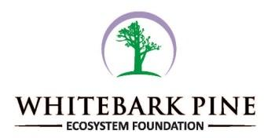 | WHITEBARK PINE ECOSYSTEM FOUNDATION  P.O. Box 17943  Missoula, MT 59808  “Working to restore whitebark pine ecosystems”

MEMBERSHIP FORM

NEW Member or RENEWING Member

Whitebark Level ($45 USD) Donation $______________

Nutcracker Level ($100 USD)

Grizzly Level ($3,000 USD)

Student Level ($25 USD) Please include copy of current student ID

Institutional Level ($150 USD) Applicable to companies and government offices

TOTAL Enclosed: $__________________

Date

Name

Address

City State/Prov Postal Code

Phone Work Home

E-Mail

Employer

Recruited by:

Membership Benefits: Members receive an annual subscription to the Nutcracker Notes e-magazine, a vote in elections, & participation in annual meetings. Membership at the Grizzly Level is a lifetime membership and annual dues are not assessed. Annual membership dues paid minus the cost of the Nutcracker Notes subscription are tax deductible. Our membership year coincides with the calendar year.

Thank you for supporting the restoration of whitebark pine ecosystems.

